 

**Internet Technology**

My Fitness Diary Web Application



Supervised by:

* Doctor Marwa N. Refaie
* Doctor Aya Saber

Submitted By:

* Dina Ahmed El Sayed Fathy G4 Cs

Table of Contents

Chapter 1 Introduction 3

1.1.Summary3

1.2.Purpose3

Chapter 2 System Analysis4

2.1. Use Case Diagram5

2.2.Class Diagram6

2.3.Sequence Diagram7

2.4.Activity Diagram8

2.5. Site Map9

Chapter 3 System Design9

3.1. Design14

3.2.1 Login15

3.2.2 Main Page16

3.2.3 BMI Page17

Chapter 4 System Implementation18

4.1. BMI Function18

4.2. BMR Function19

4.3. AMR Function20

4.4 .Calories According Goal Function21

4.5. Total Calorie Calculator / Day Function22

4.6. Meal Calorie Calculator Function22

4.7. Activity Burner Calculator Function23

Chapter 5 System Testing23

5.1. Test Cases26

Chapter 6 Used Tools and References29

6.1. Tools30

6.2. References30

**Chapter 1**

**Introduction**

**1.1.** Summary

Health and Fitness tracking Systems are one of the most important applications as now a days people care about knowing their Body Mass Index (BMI), Basal metabolic rate (BMR), Active Metabolic Rate (AMR) and Calories they need according to their different goals to maintain weight, lose weight or even gain weight. Also people care about knowing the total calories they have done per day. Some people may decide whether to eat a meal or not according to total number of calories in the meal .Moreover people care about calories they burn during activity or workout done.

**1.2.** Purpose

The purpose of ‘My Fitness Diary Web Application’ is to provide the user with data such as BMI, AMR, calories they need to lose, maintain, or gain weight so the user can understand their bodies and how they burn calories and what users should do to achieve their goals and fight against the **myth** which says that there is a type of food which causes weight gain while another types of food causes weight loss, the **truth** is that gaining or losing weight is a matter of calories in and calories out, if someone is gaining weight then for sure his calories taken in food out weights his calories consumption during the day which depends on his age ,gender, weight of his body and his activity level.

‘My Fitness Diary Web Application’ is an activity burner calculator as it can tell the user the amount of calories that he burns with doing his various daily activities. Also it provides the user with a table showing calories gained from different types of food. The user can also find many ideas about workouts, gym equipment and YouTube channels that can be done at home or even at his office during his break time.

This Web Application can be considered for the time being as a finished product to be used by users on computers but for me as the developer I consider it as just a prototype to be developed afterwards as an android and IOS version and also allow extra facilities to users and it may be with fees for memberships

Chapter 2

System Analysis

UML is a general-purpose modeling language that provides a standard way to visualize the design of a system.

Graphical models were used to facilitate presentation, documentation and implementation of the platform.

UML diagrams used are:

1. Activity diagrams, which show the activities involved in a process or in data processing.
2. Use case diagrams, which show the interactions between a system and its environment.
3. Sequence diagrams, which show interactions between actors and the system.
4. Class diagrams, which show the object classes in the system and the associations between these classes.

2.1. Use Case Diagram

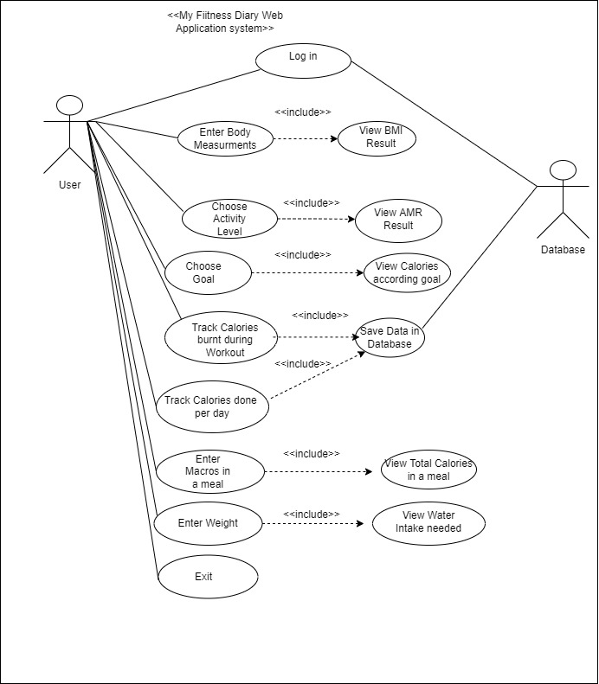

2.2.Class Diagram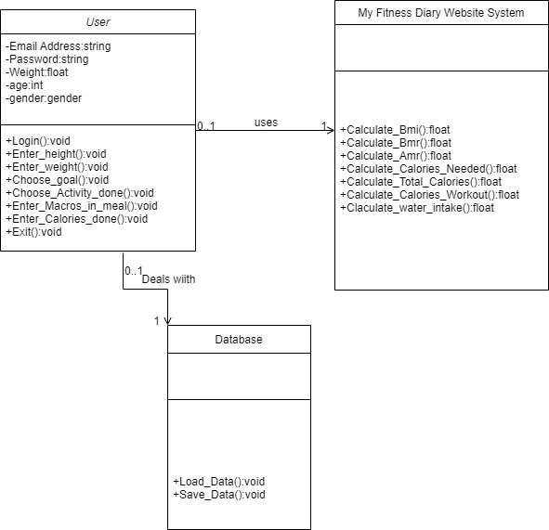

2.3. Sequence Diagram

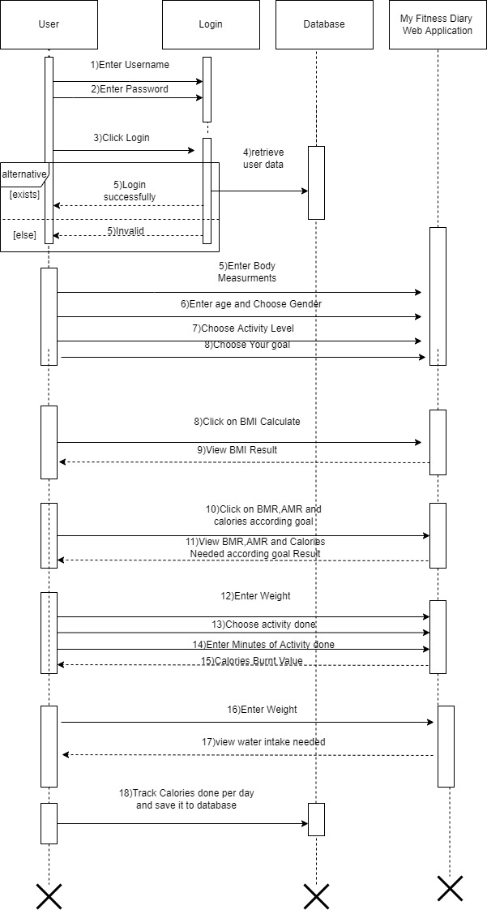

2.4. Activity Diagram

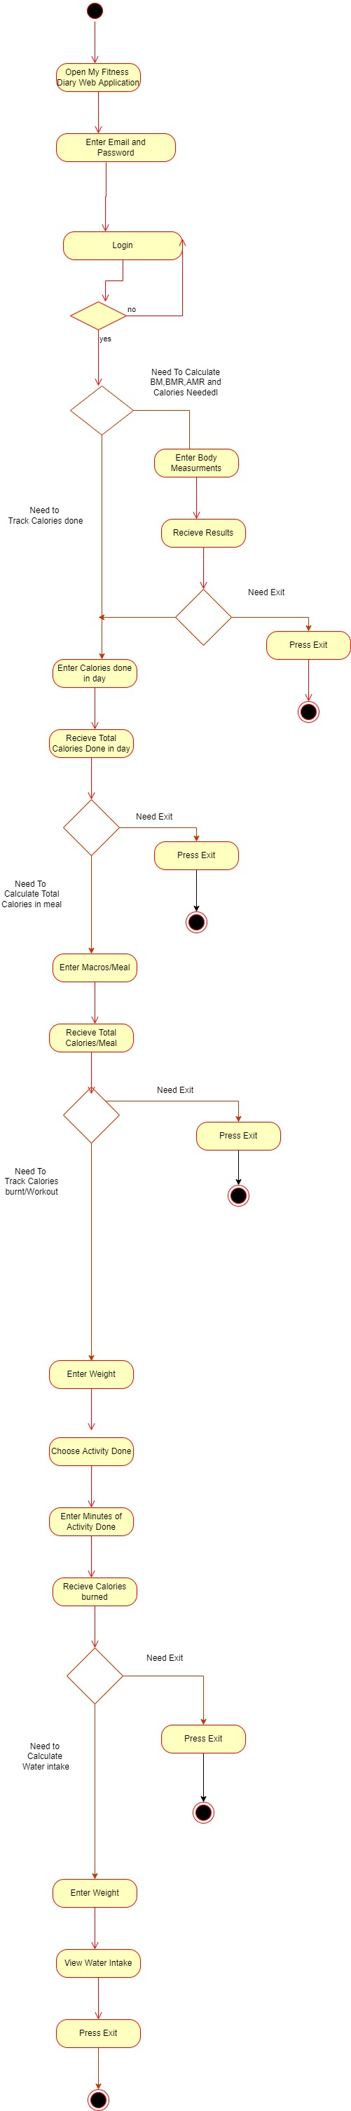

2.5. Site Map

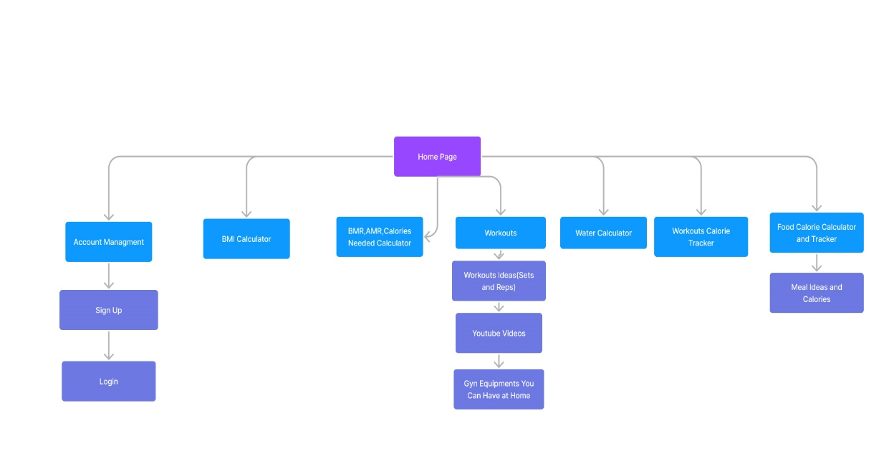

**Chapter 5**

**System Testing**

5.1. Test Cases:

|  |  |  |  |
| --- | --- | --- | --- |
| Test Case # | Process | Steps | Result |
| 1 | Login  (Invalid Process) | 1)Enter Email  2)Enter Password | Error Message  “invalid user” |
| 2 | Login  (successful) | 1)Enter Email  2)Enter Password | Login was successful |